Classic |  | Three Dimensional
Lesson Aim/Essential Question |  | Essential Question/PE
Lesson Intro/Demo (Hook) |  | Phenomena/Problem/Anchoring Experience
Using labs to confirm information |  | Using labs to construct/build understanding
Developing abilities of inquiry |  | Actively engaged in the SEPs
Integrating all areas of science |  | Emphasizing CCCs
Implementing inquiry as instructional strategies, abilities, and ideas to be learned |  | All three components of 3D learning are important to planning and instruction:  DCI – What I need to know?  SEP – How to explore/apply it?  CCC – Why I learn it?  - Students come to the classroom with conceptual models and explanations about how the world works.  - Students need to develop deep foundations of scientific knowledge, develop understanding of facts, and organize information to make sense of new phenomena.  - Metacognitive approach to teaching and learning can help students take control of their own education.  Metacognition – teaching students how to think about how they think and how they approach learning.
Role of Teacher –Direct Instructor |  | Role of Teacher –Facilitator
Students Work Individually |  | Students Work Collaboratively
Teacher uses technology to deliver information. |  | Students use technology to enhance understanding.
Engage  Phenomena/Problem/Anchoring Experience | This lesson mentally engages students with an activity or question. It captures their interest, provides an opportunity for them to express what they know about the concept or skill being developed, and helps them to make connections between what they know and the new ideas.
Explore  Hands-on/Minds-on | Students carry out hands-on activities in which they can explore the concept or skill. They grapple with the problem or phenomenon and describe it in their own words. This phase allows student to acquire a common set of experiences that they can use to help each other make sense of the new concept.
Explain  Direct Instruction | Only after students have explored the concept or skill does the teacher provide the concepts and terms used by the students to develop explanations for the phenomenon they have experienced. The significant aspect of this phase is that explanation follows experience.
Elaborate | This phase provides opportunities for students to apply what they have learned to new situations and so develop a deeper understanding of the concept or greater use of the skill. It is important for students to discuss and compare their ideas with each other during this phase.
Evaluate  Performance Task/Assessment | The final phase provides an opportunity for students to review and reflect on their own learning and new understanding and skills. It is also when students provide evidence for changes to their understandings, beliefs and skills.
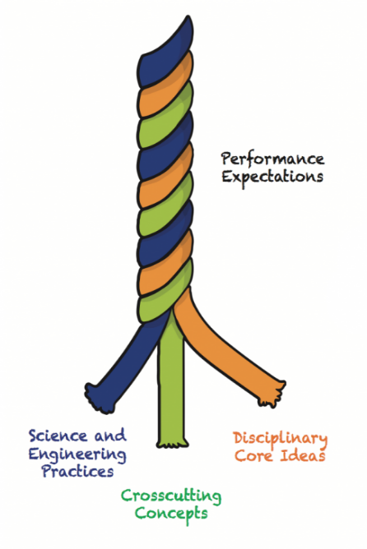

Engineering, Technology, and Application of Science
- ETS1: Engineering Design
- ETS2: Links Among Engineering, Technology, Science and Society

Earth and Space Science
- ESS1: Earth’s Place in the Universe
- ESS2: Earth’s Systems
- ESS3: Earth and Human Activity

Disciplinary Core Ideas (DCI)
NGSS and NYSSLS Planning Guide
Life Sciences
- LS1: From Molecules to Organism: Structure and Processes
- LS2: Ecosystems: Interactions, Energy, and Dynamics
- LS3: Heredity: Inheritance and Variation of Traits
- LS4: Biological Evolution: Unit and Diversity

Physical Science
- PS1: Matter and Its Interactions
- PS2: Motion and Stability: Forces and Interactions
- PS3: Energy
- PS4: Waves and Their Applications in Technology for Information Transfer

NYSSLS Glossary
NGSS – Next Generation Science Standards
NYSSLS – New York State Science Learning Standards
DCI – Disciplinary Core Idea – What the students need to know? KNOW
Evidence Statements – Collection of facts related to each topic found on the NGSS website.
CCC – Crosscutting Concepts – What will students look for? – have an application across all domains of science. UNDERSTAND
SEP – Science and Engineering Practices – How will students explore/apply? UNDERSTAND
PE – Performance Expectation (Top White Box) – What will student understand? BIG IDEA
Bundle - groups of standards arranged together to create the endpoints for units of instruction.
Phenomenon - Something that happens that provides an opportunity to ask questions and conduct research to develop scientific understanding.
Problem - A situation that requires a solution often designed and/or constructed by students
Anchoring Experience – An opportunity for students to experience phenomena in context. (Field Trips)

- Patterns
- Cause and Effect: Mechanism and Explanation
- Scale, Scale Proportion, and Quantity
- Systems and System Models
- Energy and Matter: Flow, Cycles and Conservation
- Structure and Function
- Stability and Change

- Asking Questions and Defining Problems
- Developing and Using Models
- Planning and Carrying Out Investigations
- Analyzing and Interpreting Data
- Using Mathematics and Computational Thinking
- Construction Explanations and Designing Solutions
- Engaging in Argument from Evidence
- Obtaining Evaluating, and Communicating Information

Science and Engineering Practices
(SEP)
Cross Cutting Concept
(CCC)
Phenomenon
Problem
Anchoring Experience

